Home Test-Daniel Chernov
Home Test Part A
Link to GitHub repo with the project solution:
DanielChernov99/Jones-HomeTest
Home Test Part B
Given UI: 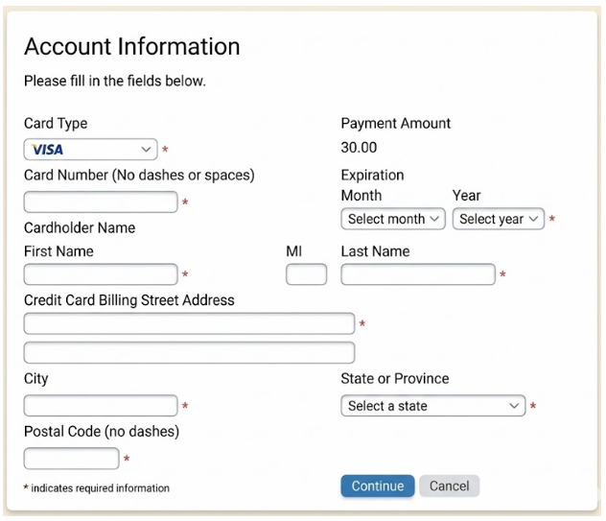

a. problems with the screen:
1. The payment amount does not show a currency.
The screen shows only “30.00”, but it is not clear if the amount is in USD, EUR, NIS, or another currency.
2. There is no Country field.
Since this is a global SaaS company, the billing form should include a country field. The country affects address format, postal code format, taxes, and payment processing.
3. State or Province should not always be required.
Not every country uses states or provinces. For example, in some countries this field may not be relevant, so the form should change based on the selected country or .
4. The “MI” field is unclear.
It is not clear what “MI” means. If it means Middle Initial, the label should be clearer. Also, the input field is very small and may confuse users.
5. Card type should be detected automatically.
Usually, the user enters the credit card number, and the system detects the card type automatically, such as Visa, Mastercard, or American Express. The user should not need to select it manually.
6. There is no CVV / security code field.
For a new credit card payment, the form usually requires a CVV or security code. Without this field, the payment flow may be incomplete, or the payment provider may reject the transaction. The CVV should be used only for payment authorization and should never be stored.
7. Card number input should allow spaces or dashes.
The screen says, “No dashes or spaces”, but many users naturally type card numbers with spaces or dashes. The system should allow this input and normalize it before validation.
8. The required field indication for expiration date is unclear.
The red asterisk appears only near the Year field, but both Month and Year are required. The UI should clearly show that both fields are mandatory.
9. Continue button should not allow invalid submission.
The Continue button appears active even when the required fields are empty. The form should not allow the user to continue before all required fields are completed and valid. A better solution would be to disable the button until the form is valid or show clear validation messages when the user clicks it.
10. The two address fields are unclear.
The billing address section has two address input fields, but only the first one is marked as required. It is not clear what the second field is for. A better label would be “Address Line 1” for the required field and “Address Line 2 / Apartment / Suite / Unit” for the optional field.

b. Tests:
Test Case 1: Successful payment
Fill all required fields with valid credit card and billing details, then click Continue.
Expected result: The form is submitted successfully, and the user continues to the next step.

Test Case 2: Invalid credit card details
Enter an invalid card number or invalid CVV, fill the rest of the required fields, then click Continue.
Expected result: The payment is rejected and a clear error message is shown.

Test Case 3: Expired credit card
Enter a valid card number but select an expired month/year, then click Continue.
Expected result: The form is not submitted, and the user sees an expiration date error.

Test Case 4: Invalid billing address
Enter a billing address that does not match the postal code or state, then click Continue.
Expected result: The system shows a billing address validation error.

Test Case 5: Required fields are empty
Leave required fields empty and click Continue.
Expected result: The form is not submitted, and validation messages are shown for all missing required fields.

Test Case 6: Invalid or missing cardholder name
Leave the cardholder’s name empty or enter invalid characters/numbers, then click Continue.
Expected result: The form is not submitted, and a clear name validation error is shown.

c. Solution for the severe bug:
In my opinion, one of the most severe issues in this screen is that there is no CVV / security code field.
For a new credit card payment, the CVV is usually an important part of the payment authorization process. Without it, there is a high chance that the payment will fail or be rejected by the payment provider. This is especially critical for the SaaS business, because successful billing is one of the most important parts of the product.
The product solution is to add a CVV / security code field to the payment form and validate it based on the selected card type. For example, most cards use a 3-digit CVV, while American Express usually uses a 4-digit code.
The CVV should only be used for payment authorization and should never be stored. A better long-term solution would be to use a trusted payment provider with hosted payment fields and tokenization, so the application does not directly handle sensitive credit card data.

